Assignment 4



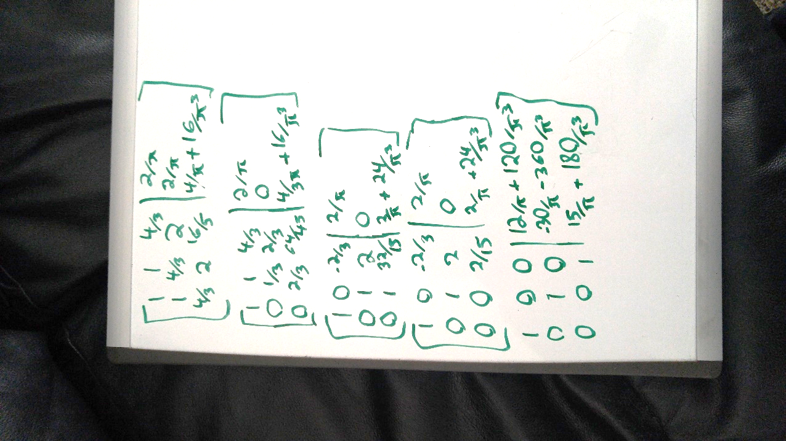

No, my results from this question and from the midterm are very different. My results from the midterm only relied on 3 points of sin(pi\*x/2), with more points comes a more accurate solution.

1. Initially for 2 I did my calculations by hand:

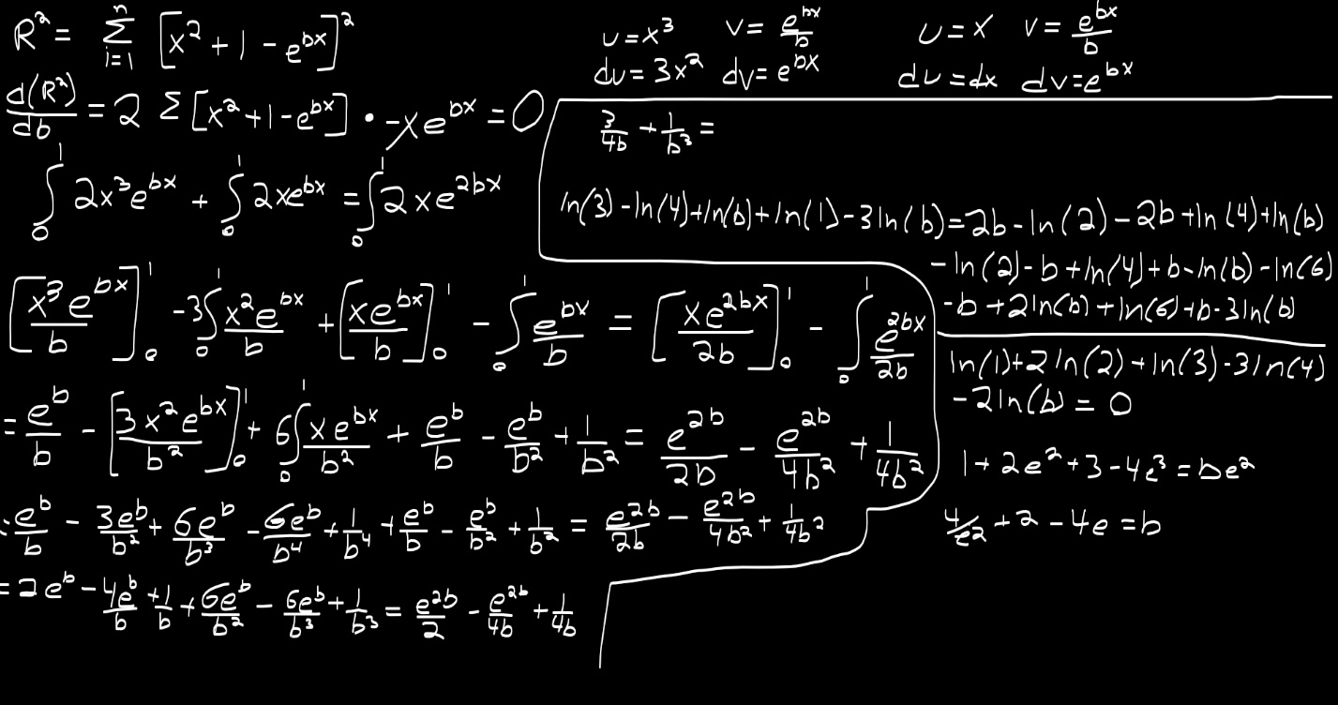

But I ran into a number of mistakes… as such I used wolfram alpha to compute everything past my first step, d(R^2)/db

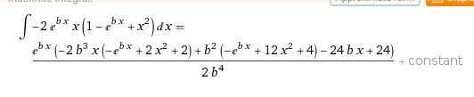

I then simplified wolframs answer by hand and plugged in x = 1 and x = 0 respectively

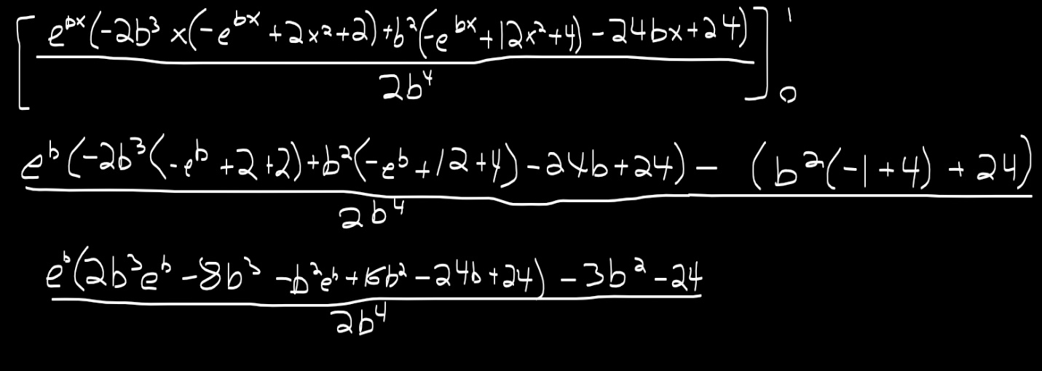

I tried to enter this into both matlab and wolfram but I could not figure out how to find the root in matlab so I turned to wolfram for the answer.

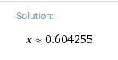

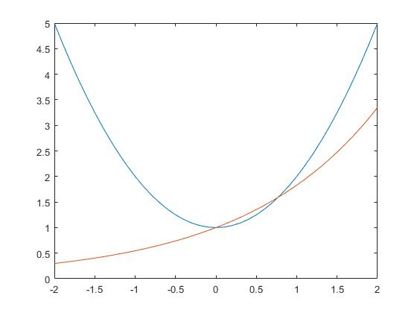







Using matlab:

A = [5 -2 3; -3 9 1; 2 -1 -7];

B = [-1; 2; 3];

X = linsolve(A,B)

X =

0.1861

0.3312

-0.4227